Tutorial for Students, Faculty, & Staff – SERVE.truman.edu
Note: If you would like assistance in exploring the website or would like for a SERVE team member to present the website to your organization or class, please contact the SERVE Center at serve@truman.edu.

Step 1: Log-In or Create an Account Page 1
Step 2: My Profile Page 2
Step 3: My Activities Page 3
Step 4: My Service Hours Page 4
Step 5: My Service Resume Page 5
Step 6: Browse One Time Activities Page 6
Step 6a: Filter Activities by Category Page 7
Step 7: Browse Current Ongoing Activities Page 8
Step 8: Browse Potential Ongoing Activities Page 9
Step 9: Browse Community Partners Page 10
Step 10: Student Organizations Page 11
Step 10a: View an Organization Page 11
Step 10b: View an Organization’s Statistics Page 12
Step 11: Teams and Courses Page 13
Step 12: Cocurricular Record Page 14

Step 1: Log-In or Create an Account
- ‘Enroll or Sign-In,’ click on ‘Truman Students, Faculty, & Staff’ and use your Truman username and password to log-in

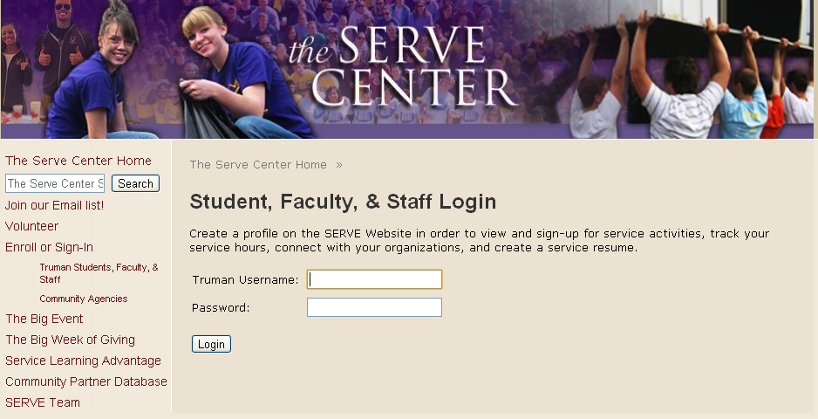

Step 2: My Profile
- Add your personal contact information, graduation year, and Volunteer Interests
  - You can also select multiple organizations, teams, and/or courses to become an online member
- Important: Select Submit or Update after you make changes on each page

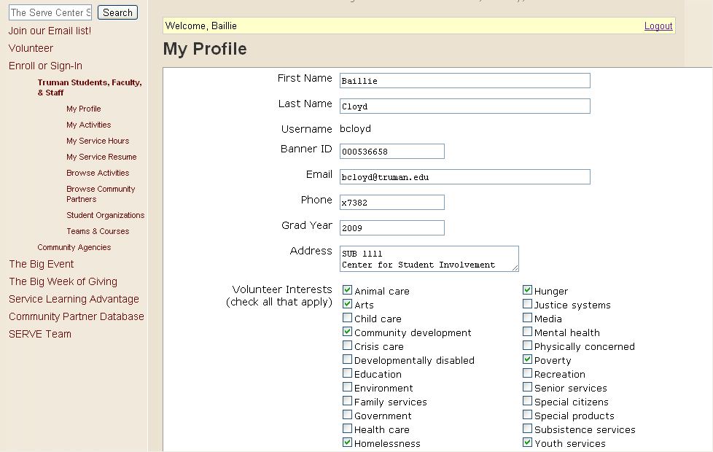

(Top)

Step 3: My Activities – These are activities for which you have actually signed up to volunteer and will attend
- Once you have signed up to volunteer for activities (Step 6 and Step 7), they will appear here
  - You can search for activities by clicking on ‘Add Activities’ below each section (more to come)
- There are One Time and Ongoing activities
  - Ongoing activities are service projects that occur for more than one specific date or time
  - One Time activities are service projects that occur on a specific date or time
- Important: You can click on an activity (see 3/26/2011 – Spring Expo), more information will appear, including the time, location, contact information, and number of volunteers currently signed up for the event
- You can delete an event from your activities by clicking on the red circle with the slash through it

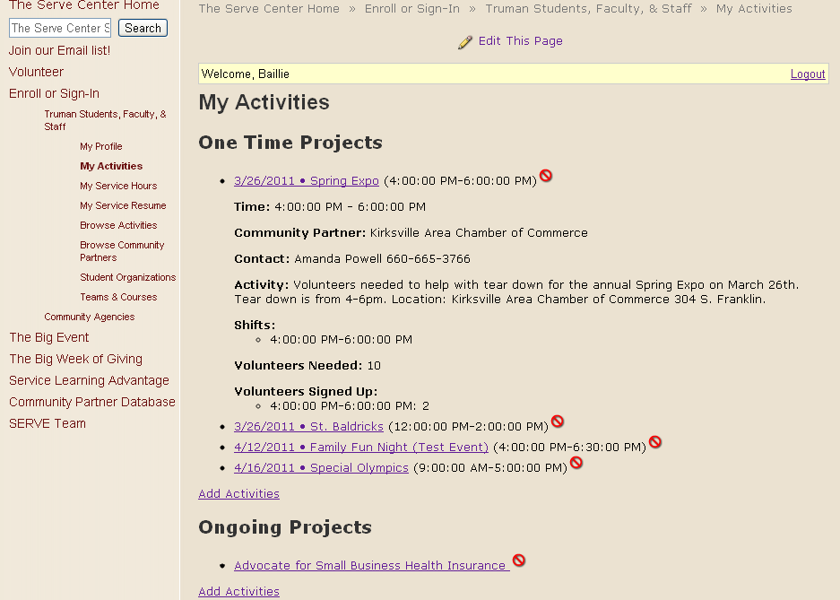

(Top)

Step 4: My Service Hours
- Once you have signed up for and completed a volunteer activity, you can log your service hours here
- Click on an activity (See Love INC Food Distribution below), and the option to view your current hours and add new hours will appear
  - You can delete hours you have already logged by clicking on the red circle with a slash through it
  - You can add new hours by selecting the ‘Date,’ adding the ‘Number of Hours’ and clicking ‘Add’
- Important: You can add service projects you completed on your own or with a group, but did not appear on the website’s list of activities
  - Under ‘Other Projects,’ click ‘Add’
  - A separate screen will appear and ask for the ‘Project Name’ and ‘Project Description’
  - You can then add hours the same as explained above
- Your Total Hours completed appears at the bottom of each section and at the bottom of the page

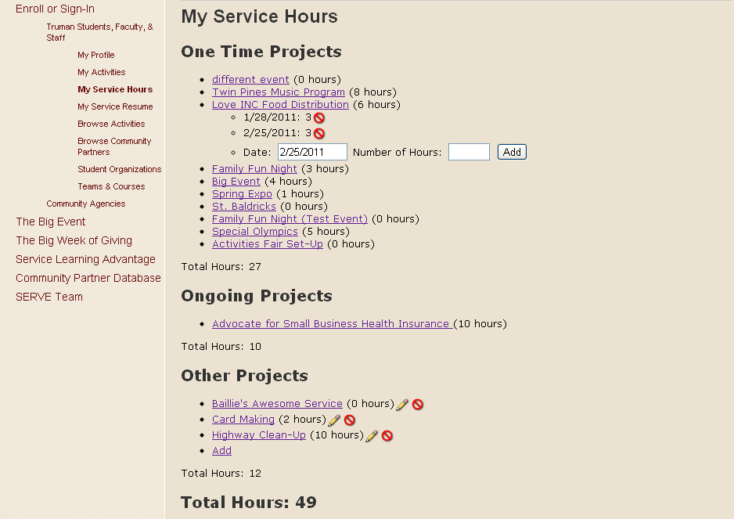

(Top)

Step 5: My Service Resume
- By clicking on ‘My Service Resume’ on the left hand side, you can view a summary with project names, project descriptions, project dates, and volunteer hours completed from the entire semester
  - Your Total Number of Service Hours appears at the bottom of the Resume

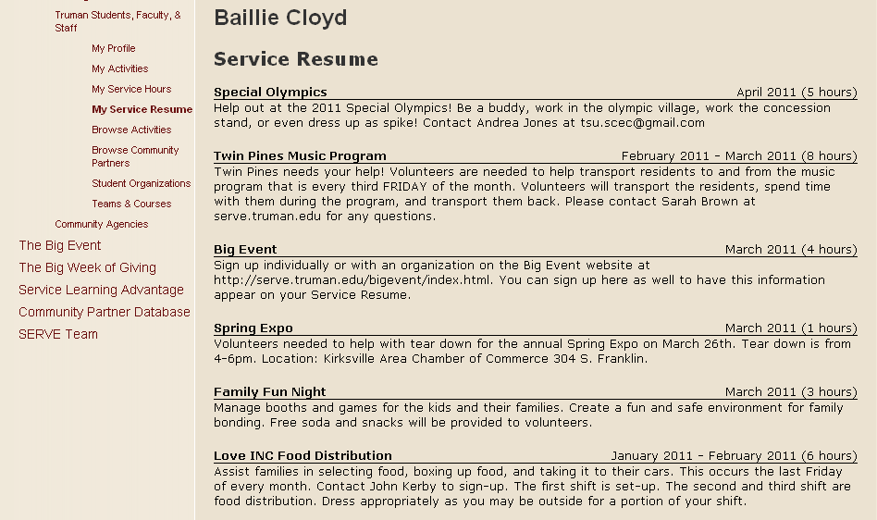

(Top)

Step 6: Browse One Time Activities
- To sign up for an activity, click on ‘Browse Activities’ on the left hand menu
- First, you can view One Time Activities
- If you click on an activity (See 4/12/2011 – Family Fun Night (Test Event) below), you can see all of the pertinent information for the activity
  - If the event has multiple shifts, you can sign up for one or all of the shifts by clicking the green box: ‘Add to My Activities’
  - You can also remove an activity you had previously signed up for by clicking the red box: ‘Remove from My Activities’
- Important: You can see how many volunteers are needed for an activity
  - You can also view how many people have currently signed up for each activity/shift

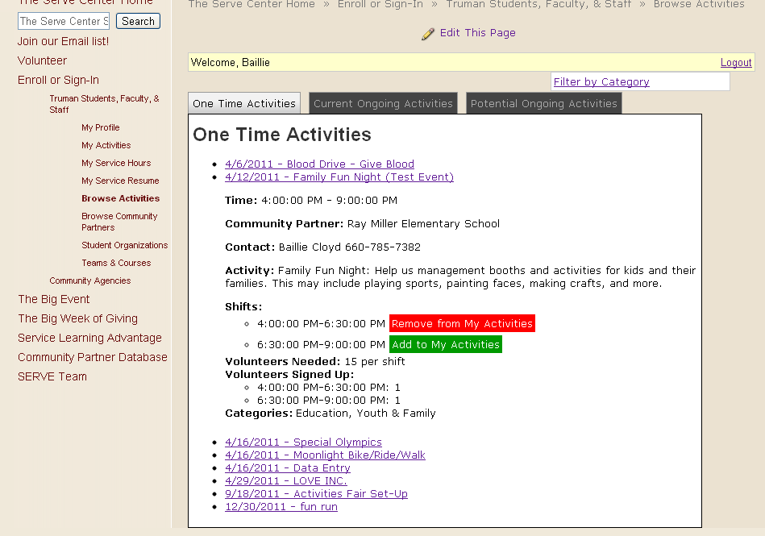

(Top)

Step 6a: Filter Activities by Categories
- You can ‘Filter’ or sort the activities by a certain category that you are interested in
- Click on ‘Filter by Category’ and the options will appear
- As can be seen in Image 2 below, only one activity (Special Olympics) appears when you filter by ‘Disabilities’

Image 1
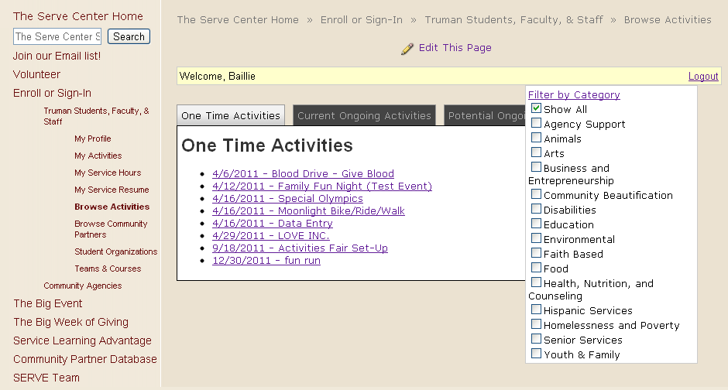

Image 2
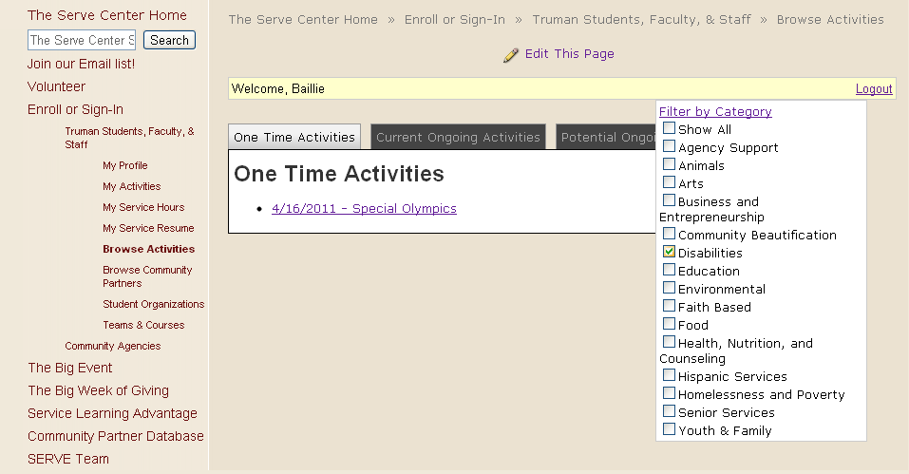

(Top)
Step 7: Browse Current Ongoing Activities
- Current Ongoing Activities are ongoing service projects that you can sign up for now
  - Ongoing means that you are needed to volunteer for more than just one date/time
- When you click on an activity (See Adair County Historical Society below), more information will appear
- You can Add Activities, Remove Activities, and Filter Activities the same as in Step 6
- As can be seen in Image 2, you can hover the mouse over the ‘Community Partner’ link to see more information about the agency and their website

Image 1
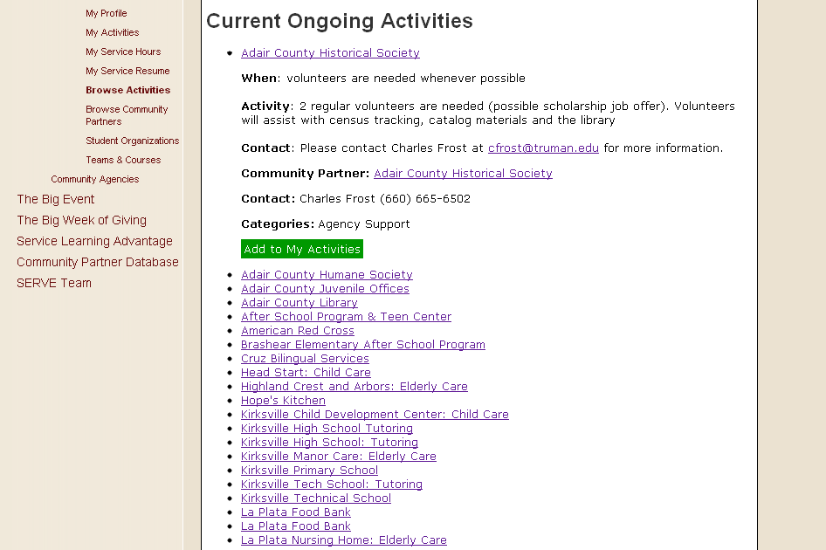
Image 2
(Top)

Step 8: Browse Potential Ongoing Activities
- Potential Ongoing Activities are projects that have been recommended by either the Truman or Kirksville community as projects that could be initiated by Truman students, organizations, and/or classes
- By clicking on an activity (See Analyze Delivery Routes below), you can view more information and ideas
- You can Add Activities, Remove Activities, and Filter Activities the same as in Step 6
- Important: These projects are merely suggestions and have not yet been started

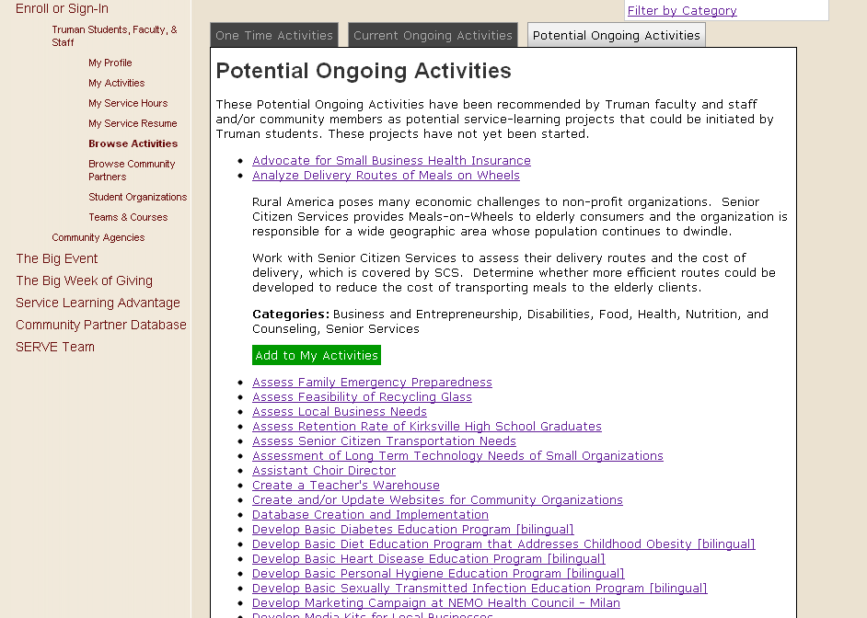

(Top)

Step 9: Browse Community Partners
- Community Agencies/Partners are organized alphabetically by their primary category or area of service (i.e. Education, Disabilities, etc.)
  - If you click on an agency (See United Way below) more information will appear
- Important: Image 2 shows that if a Community Partner is sponsoring a current activity/service project, it will appear on this page as well
  - You can Add Activities, Remove Activities, and Filter Activities the same as in Step 6

Image 1
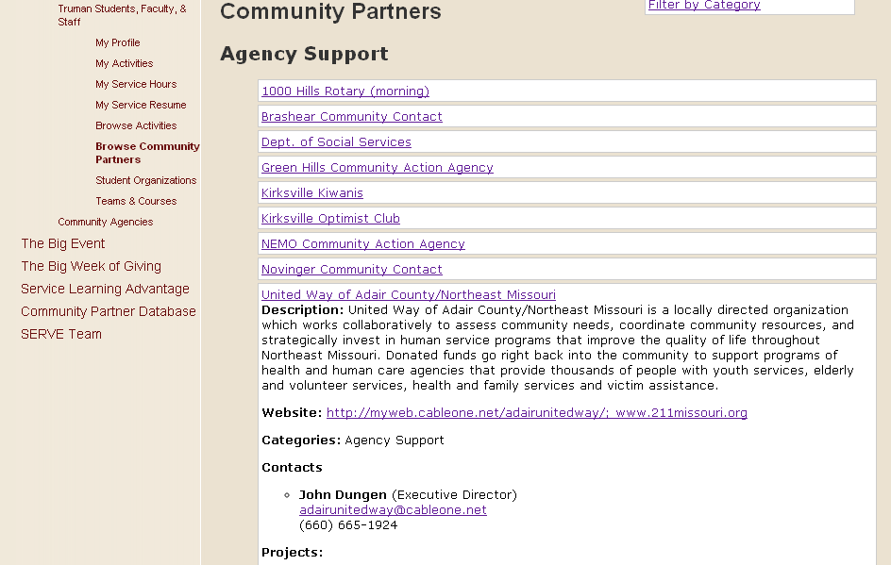
Image 2
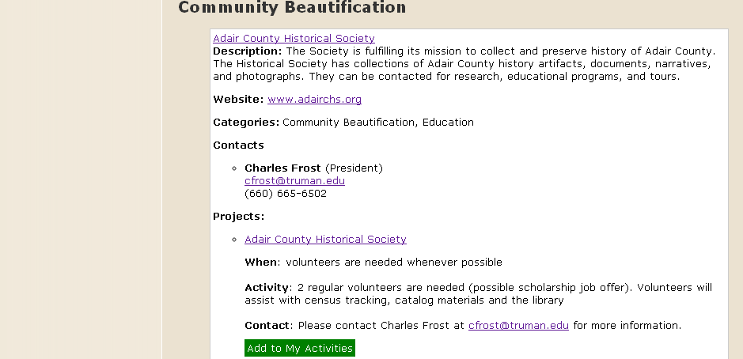

(Top)
Step 10: Student Organizations
- By clicking on ‘Student Organizations’ on the left hand menu, you can view the organizations that you selected on your profile page
- If you are listed as an office for an organization, you can click a link to see more (See SERVE Center below) like in Step 10a below
- If you are not listed as an officer for an organization, you will not be able to click a link (See Campus Crusade for Christ below)

Step 10a: View an Organization
- If you can view an organization, it will take you to this screen
- You can add/remove members, make members officers, and select Volunteer Interests for the organization
  - To make a member an officer, you can check the box listed under their Member name
  - Important: Only officers can view an organization’s information; All current officers are listed as the President in the CSI Organization Database
  - Important: Individuals can become members of an organization on the website by either (1) selecting the organization on their profile or (2) having an officer enter their username below
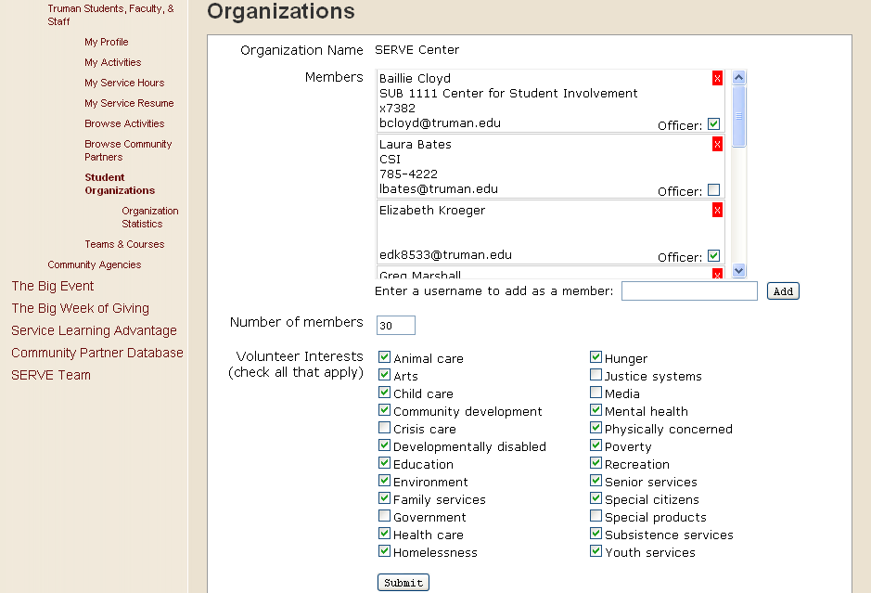

Step 10b: View an Organization’s Statistics
- To view the service statistics for your organization, click on ‘Stats’ like in Image 1
- You can view the number of hours completed by your organization’s members by selecting a date range either on the Calendar or by typing in dates – The hours appear by member (under Export)
- Important: You can also Export the information to an Excel Spreadsheet, which allows you to view the service completed by each member broken down by service project and the number of hours completed for each project (See Image 3 below)

Image 1
Image 2
Image 3
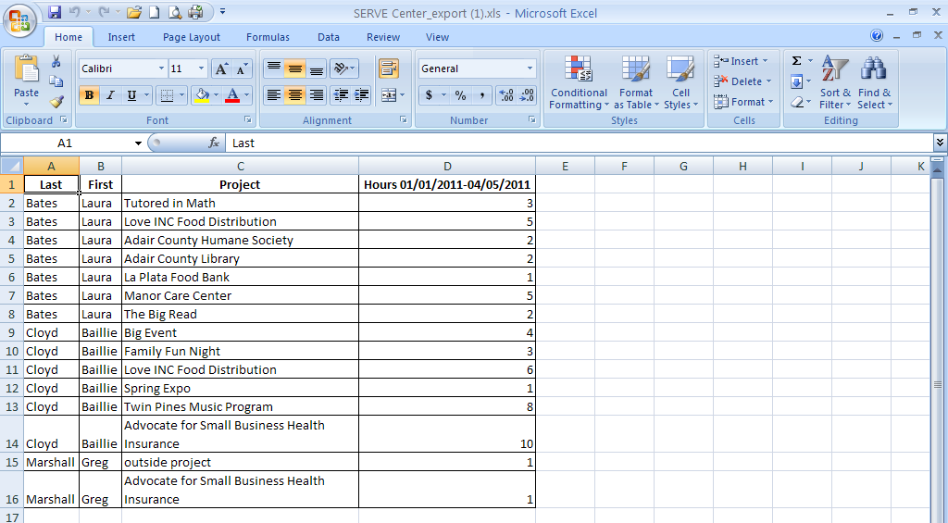
Step 11: Teams and Courses
- Teams and Courses work the same as Student Organizations (See Step 10 for details)
- Coaches and Professors can see the hours and projects submitted by each students who is signed up for their team or course

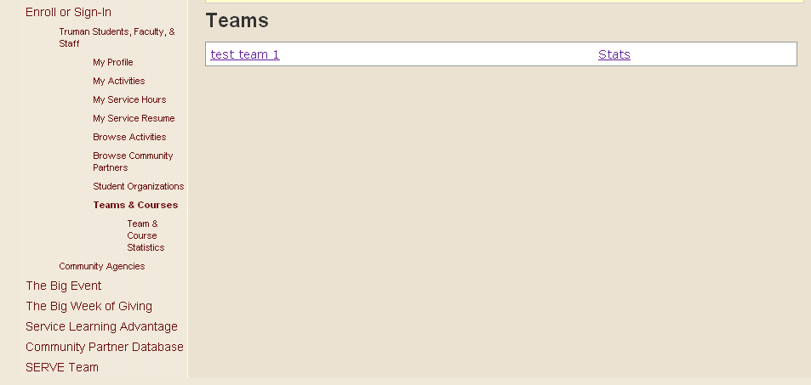

(Top)
Step 12: Service Recognition on your Cocurricular Record
- In order to receive service recognition on their Cocurricular Record, students must 1) track their service hours via the SERVE website and 2) adequately reflect on the experience
- Once a student reaches an award level (see below), they will automatically receive a generalized email explaining the recognition and reflection process
- Students will also be recognized at the Leadership Recognition Program in the spring

Award Levels:
- Gold Service Award: 100 hours per year (approx. 50 hours per semester)
- Silver Service Award: 80 hours per year (approx. 40 hours per semester)
- Bronze Service Award: 60 hours per year (approx. 30 hours per semester)

Reflection
In order to receive credit on the cocurricular record, students must reflect on their service experience and how it has impact their time at Truman
- Gold & Silver Service Award:
  - Complete an online Cocurricular Journal entry
  - Attend a STAR Reflection Session (hosted by the SERVE Center)
- Bronze Service Award:
  - Complete an online Cocurricular Journal entry

(Top)

