Tutorial for Community Agencies – SERVE.truman.edu

Step 1: Log-In or Create an Account Page 1
Step 2: My Profile Page 2
Step 3: Agency Profile Page 3
Step 4: Ongoing Activities Page 4
Step 5: Add an Ongoing Activity Page 5
Step 6: Update an Existing Ongoing Activity Page 6
Step 7: View or Contact Volunteers Page 6
Step 8: One Time Activities Page 7
Step 9: Add a One Time Activity Page 8
Step 10: Update an Existing One Time Activity Page 9
Step 11: View or Contact Volunteers Page 10

Step 1: Log-In or Create an Account
- If you already have a Truman username and password, you can log-in at serve.truman.edu by clicking ‘Community Agencies’ under ‘Enroll or Sign-In’
- If you do not have a Truman username or password, please contact the SERVE Center at serve@truman.edu

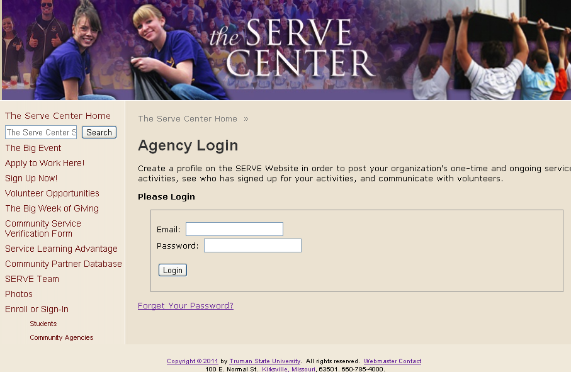

(Top)
Step 2: My Profile
- Add your personal contact information and position title
- Important: Select Submit or Update after you make changes on each page
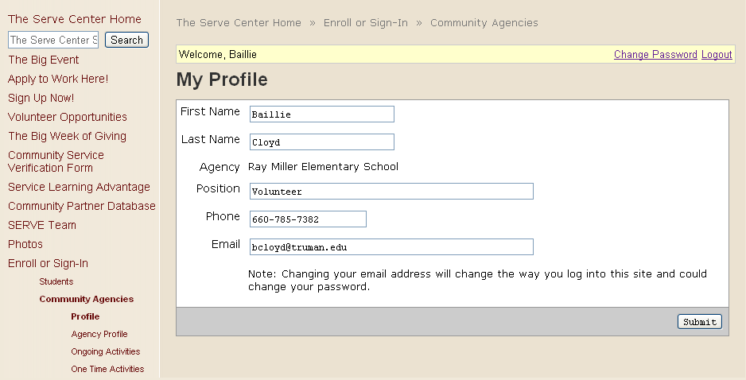

(Top)
Step 3: Agency Profile
- Update your agency information – add a link to your website, a description of your services, and select categories that describe your agency and your services
- Contacts for your agency must each create their own profile – the SERVE Center will link them to your agency

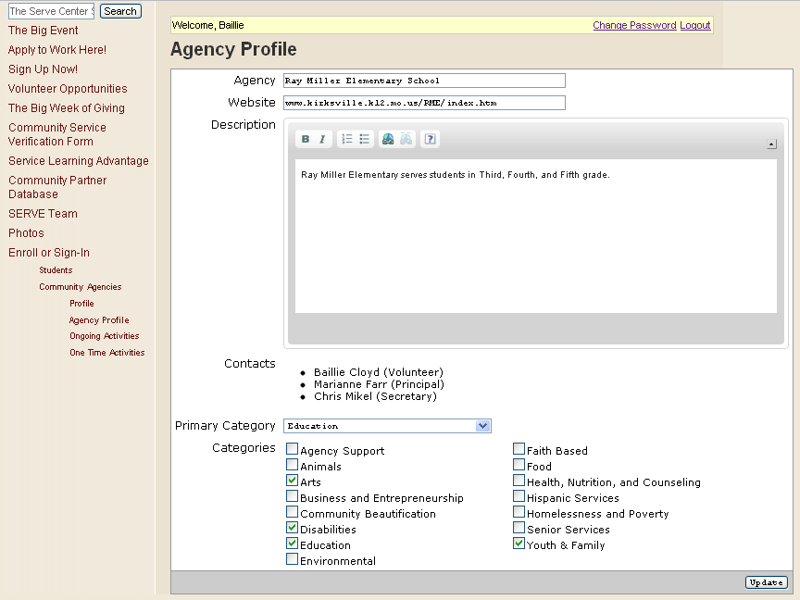

(Top)

Step 4: Ongoing Activities
- Ongoing activities are service projects that occur for more than one specific date or time
  - Examples include weekly or monthly activities, like tutoring, child care, or adopting a grandparent
- Click on ‘Ongoing Activities’ to add new service activities, update existing activities, or see volunteers who have signed up for your activity
- Click ‘Add New’ to create a new activity (Step 5)
- Click on an existing activity (see Ray Miller Elementary: Tutoring below) to update the activity (Step 6)
- Click the number (see the 1 below) on the same line of the existing activity to see the volunteers (Step 7)

(Top)

Step 5: Add an Ongoing Activity
- After you click ‘Add New’ (See Step 4), you can add the project name, the contact person from your agency, a description, and the categories that apply to this project
- Important: Status
  - Choose ‘Current’ from the Status drop down box if the project is a scheduled activity students can sign-up for now
    - Example: Existing tutoring programs
- Choose ‘Potential’ from the Status drop down box if the project is an idea that you would like students to take the initiative to implement on their own
    - Example: You want someone to build a new playground at your facility, but don’t have the time or resources to do it yourself and want students to instigate the project

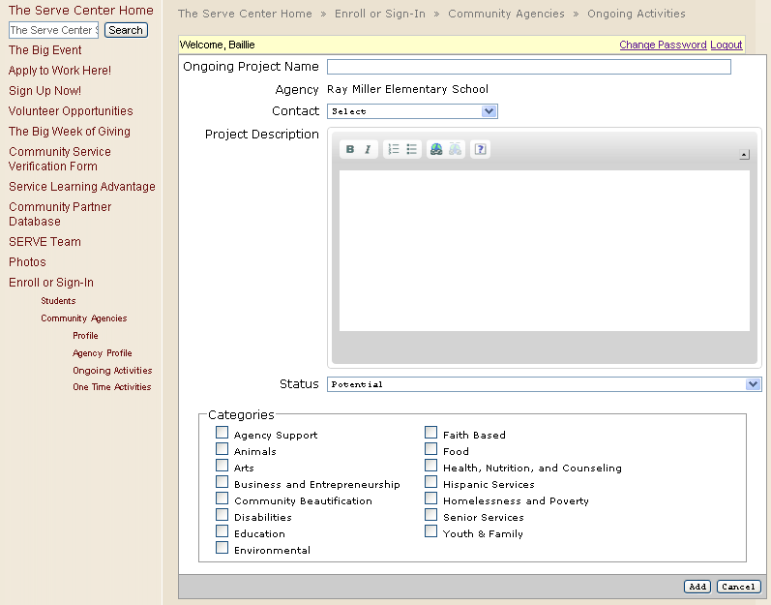

(Top)

Step 6: Update an Existing Ongoing Activity
- After you click on the activity (See Step 4), you can change any of the information you previously entered
- Don’t forget to check the Status

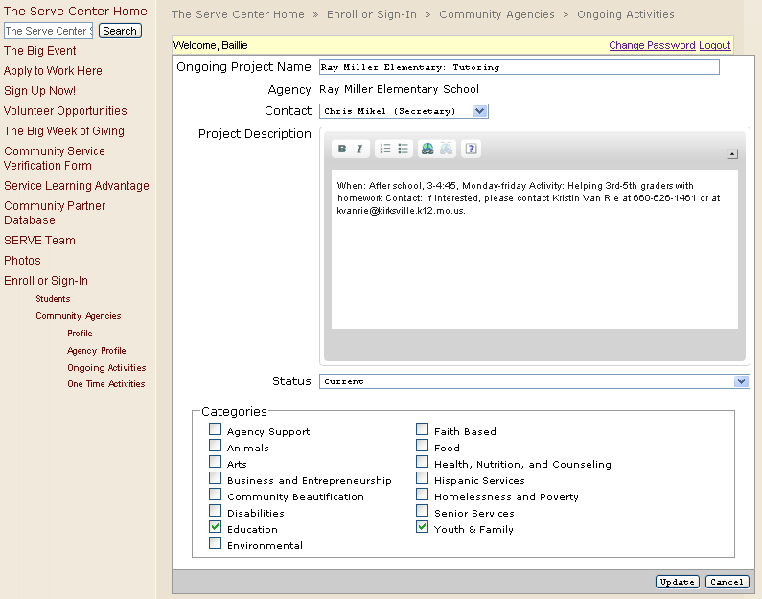

Step 7: View or Contact Volunteers
- After you have clicked on the number proceeding the activity name (See Step 4), you can view the activity details and the volunteers that have signed-up online
  - You have access to their names, emails, and how many hours they have logged for the activity
  - You can contact them if project details change or to discuss their service

(Top)
Step 8: One Time Activities
- One Time activities are service projects that occur on a specific date or time
- Click on ‘One Time Activities’ to add new activities, update existing activities, or see who has signed up for your activity
- Click ‘Add New’ to create a new activity (Step 9)
- Click on an existing activity (see Family Fun Night below) to update the activity (Step 10)
- Click the number (see the 2 below) on the same line of the existing activity to see the volunteers
(Step 11)

(Top)

Step 9: Add a One Time Activity
- After you click ‘Add New’ (See Step 8) you can add the project name, the contact person from your agency, a description, the location of the activity, and the categories that apply to this project
- You can also add the activity date and time and even use shifts, if it is a longer activity or you need students for multiple activities
- List the number of volunteers you need to make sure you don’t have too many or too few volunteers sign-up

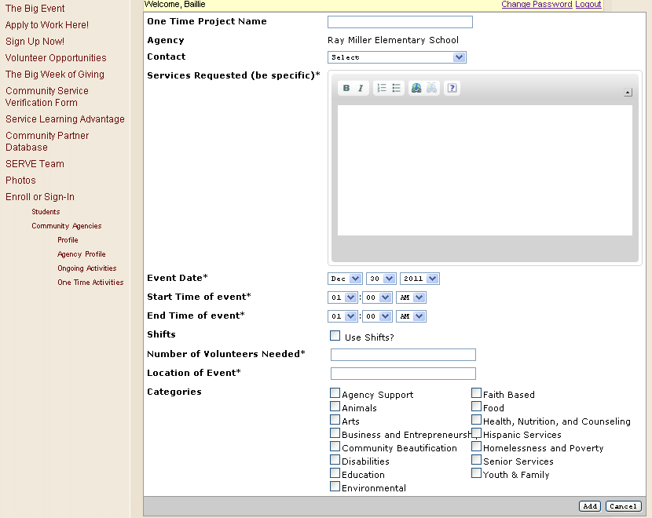

(Top)

Step 10: Update an Existing One Time Activity
- After you click on the activity (See Step 8), you can change any of the information you previously entered

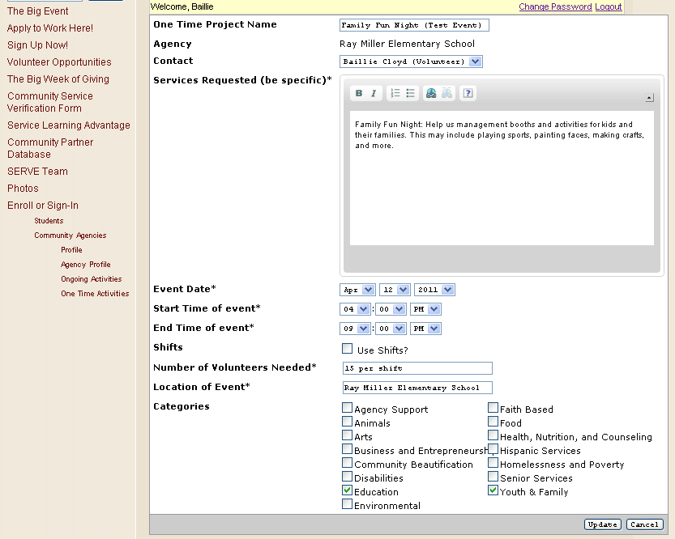

(Top)

Step 11: View or Contact Volunteers
- After you have clicked on the number proceeding the activity name (See Step 8), you can view the activity details and the volunteers who have signed-up online
  - You have access to their names, emails, and how many hours they have logged for the project
  - You can even see who has signed-up by shift
  - You can contact them if project details change or to discuss their service

(Top)

